TO ACCESS THE ROOM BOOKING CALENDARS USING WEB OUTLOOK

1. CLICK ON THE SHARE BUTTON

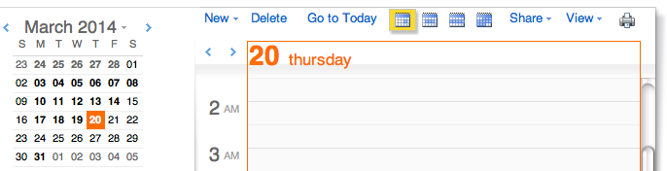

2. FROM THE DROP DOWN MENU SELECT THE ADD CALENDAR OPTION

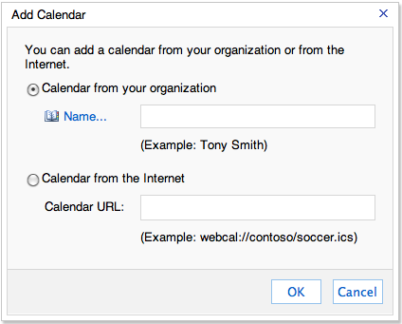

3. CLICK ON THE NAME…. BUTTON AND THEN SEARCH THE ADDRESS BOOK FOR THE MEETING ROOM CALENDAR YOU ARE LOOKING FOR BY TYPING THE FIRST FEW LETTERS OF THE ROOM NAME AND NUMBER
